Practical 1
Code:-
print("======STUDENT DETAILS======")
name=str(input("Enter your name:"))
age=int(input("Enter your age:"))
roll_no=int(input("Enter your roll no:"))

print("=====STUDENT DETAILS===")
print("Name is:",name)
print("Age is:",age)
print("Roll NO is:",roll_no)
OUTPUT:-
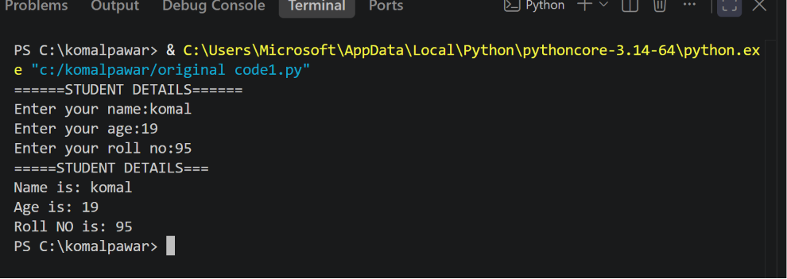

Exercises
Q.01 Develop a program that accepts a student’s marks for three different subjects,
Calculate their total and average and prints final scorecard with the average rounded to two decimal places.
Code:-
name=input("Enter your name: ")

marks1=float(input("Enter your marks of subject1: "))
marks2=float(input("Enter your marks of subject2: "))
marks3=float(input("Enter your marks of subject3: "))

total = marks1+marks2+marks3
average=total / 3

print("======== Display score card ==========")
print("subject1",marks1)
print("subject2",marks2)
print("subject3",marks3)
print("Total marks",total)
print("Average",round(average))
print("---------------------------")
Output:-

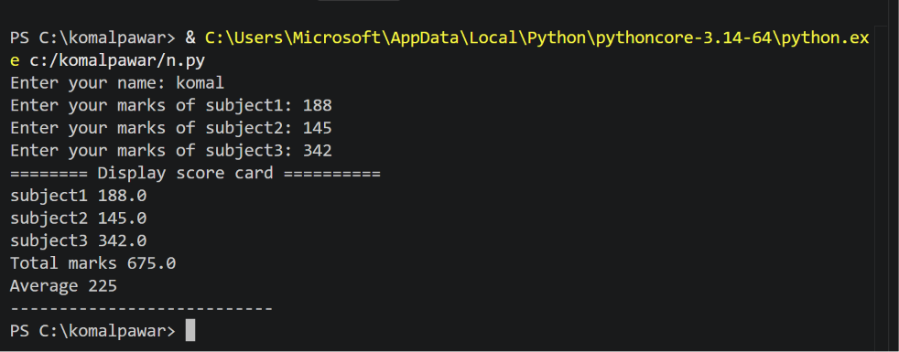
Q2. Create a simple profile generator that takes an employee’s name, role, and monthly salary and prints out a formatted text based employee identity card
Code:-
name=(input("Enter employee name :"))
role=(input("Enter employee role :"))
salary=int(input("Enter employee salary :"))

print("==============================")
print(" EMPLOYEE IDENTITY CARD ")
print("==============================")
print("name",name)
print("role",role)
print("salary",format(salary))
print("==============================")
Output:-
